Experiment Number : 02 Date: 28.01.26

Input and Output Statements in Java
Aim:
To understand and use input and output statements in Java using the Scanner class.
PRE LAB EXERCISE
QUESTIONS
1.What is input in a program?
Input in a program refers to the data or information that is provided to the program for processing. This data can come from various sources such as the user (via keyboard), files, sensors, or other programs. Input allows a program to operate dynamically rather than working only with fixed values, enabling it to perform different tasks based on the data it receives.
2.What is output in a program?
Output in a program is the result produced after the program processes the given input. It represents the information that the program sends back to the user or another system. Output can be displayed on the screen, stored in a file, sent over a network, or used as input for another program. It helps users understand the outcome of the program’s execution.
3.Which class is used to read input from the user in Java?
In Java, the Scanner class is commonly used to read input from the user. The Scanner class belongs to the java.util package and provides methods to read different types of data such as integers, floating-point numbers, and strings from the keyboard (standard input). It simplifies user input handling and is widely used in beginner and intermediate Java programs.

IN LAB EXERCISE
Objective:
To read input from the user and display the output using Java input and output statements.
INPUT STATEMENT:
SCANNER CLASS
- The Scanner class in Java is used to read input from the user through the keyboard.
It is available in the package java.util.
- The Scanner object reads different types of input such as integer, float, double, and string and stores them in variables.
- To use the Scanner class, it must be imported before using it in the program.
SYNTAX:
- Scanner sc = new Scanner(System.in);
Commonly Used Scanner Methods:
- nextInt() – reads an integer value
- nextFloat() – reads a float value
- nextDouble() – reads a double value
- next() – reads a single word
- nextLine() – reads a complete line of text

PROGRAMS:
Program 1: Read and Display Name
Source Code:
import java.util.Scanner;
class ReadName {
public static void main(String[] args) {
Scanner sc = new Scanner(System.in);
System.out.print("Enter your name: ");
String name = sc.nextLine();
System.out.println("Your name is: " + name);
}
}
Output:
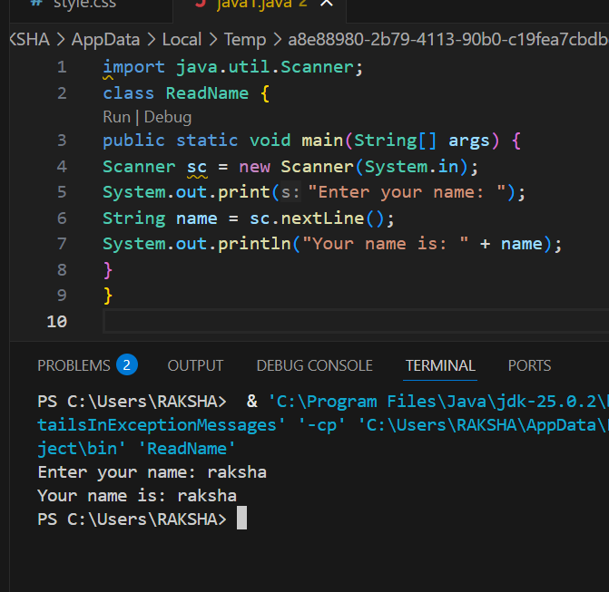
Enter your name: Anitha
Your name is: Anitha
Program 2: Read Two Numbers and Print Sum
Source Code:
import java.util.Scanner;
class SumInput {
public static void main(String[] args) {
Scanner sc = new Scanner(System.in);
System.out.print("Enter first number: ");
int a = sc.nextInt();
System.out.print("Enter second number: ");
int b = sc.nextInt();
int sum = a + b;
System.out.println("Sum = " + sum);
}
}
Output:
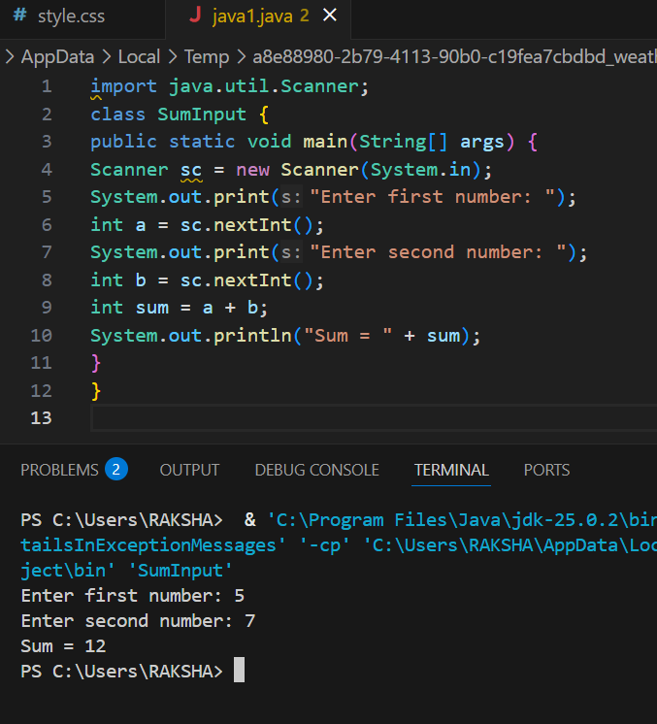
Enter first number: 5
Enter second number: 3
Sum = 8
Program 3: Read Length and Breadth and Find Area of Rectangle
Source Code:
import java.util.Scanner;

class AreaRectangleInput {
public static void main(String[] args) {
Scanner sc = new Scanner(System.in);
System.out.print("Enter length: ");
int length = sc.nextInt();
System.out.print("Enter breadth: ");
int breadth = sc.nextInt();
int area = length * breadth;
System.out.println("Area of Rectangle = " + area);
}
}
Output:
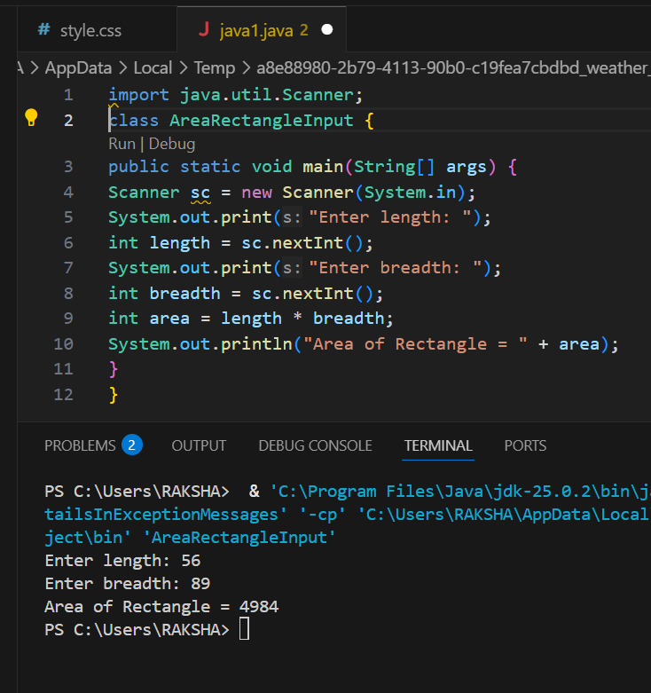
Enter length: 10
Enter breadth: 5
Area of Rectangle = 50

POST LAB EXERCISE
- 1.What is the use of the Scanner class in Java?
- The Scanner class in Java is used to read input from various sources such as the keyboard, files, or strings. It allows the program to accept user input in different data types like integers, floating-point numbers, characters, and strings, making interaction with the user simple and efficient.
- 2. Which package contains the Scanner class?
- The Scanner class is contained in the java.util package.
- System.in represents the standard input stream in Java. It is used to receive input data from the user, usually through the keyboard.
- 3.What does System.in represent?
- System.in represents the standard input stream in Java. It is used to receive input data from the user, usually through the keyboard.
4.What does System.out represent?
- System.out represents the standard output stream in Java. It is used to display output or results of the program on the screen
- 5.Name any two methods used to read input using Scanner.
- Two commonly used methods of the Scanner class are:
- nextInt() – to read an integer value
- nextLine() – to read a line of text
- 6.What is the difference between next() and nextLine()?
- The next() method reads input only up to the next whitespace (space, tab, or newline), whereas the nextLine() method reads the entire line of input, including spaces, until the Enter key is pressed.

Result:

Thus the input was successfully read from the user and the corresponding output was displayed using Java input and output statements.

ASSESSMENT

Description | Max Marks | Marks Awarded
Pre Lab Exercise | 5
In Lab Exercise | 10
Post Lab Exercise | 5
Viva | 10
Total | 30
Faculty Signature

